CSE 219 — Signals and Linear Systems
Lec 1–2 · Signals: Energy, Transformations, Even–Odd, Step & Impulse, Periodicity
Lesson notes · Exam approach · TF practice with solutions · Quick notes (Anik Sir's portion)

How to Read These Notes
EXAM FOCUS | Exam importance, where it appears in the TF collection
MEMORIZE | Rules, tables and formulas to memorize
TRAP | Common mistakes and exam traps
EXAM-READY ANSWER | Model wording you can write in the exam
NOTE | Extra explanation / clarification
Grey box, monospace | Code, worked tables, derivations and hand-drawn sketches
Centered grey box | Formula to remember / final numerical result
Purple heading / ✔ green | Practice questions / their solutions

Contents
Exam Map — What the TF Papers Ask — signal-basics questions and how much they matter
Lesson 1 — Energy and Power — E and P in CT and DT; energy vs power signals
Lesson 2 — Time Shifting, Reversal and Scaling — the x(αt+β) recipe, sketches step by step
Lesson 3 — Even and Odd Decomposition — x_e, x_o for piecewise CT and DT signals
Lesson 4 — Unit Step, Unit Impulse, Ramp and Signals Built from Them — δ = du/dt, sifting, jumps → impulses, δ models
Lesson 5 — Exponentials, Sinusoids and Periodicity — CT and DT periodicity, sums of sinusoids
Quick Notes — Signals — merged revision notes + key diagrams
NOTE Slide numbers refer to Lecture-1-A-Little-Introduction-to-Signals.pdf (53 slides, “Lec 1”) and Lecture-2-Some-Useful-Signals.pdf (51 slides, “Lec 2”). Questions are labelled by session and course: CSE 219 = this course (pages in the merged TF PDF or “22 batch p.N”); EEE 211 / EEE 301 = the EEE department's Continuous Signals and Linear Systems papers, same content (pages “EEE p.N”). Ramp functions, impulse scaling and δ′(t) are textbook background (marked).

Exam Map — What the TF Papers Ask
Signal basics open almost every paper. In CSE 219 they are the first Anik-section questions (2022-23 Q5(a), Q7; 2023-24 Q1(a), Q3(a)); in the EEE papers they are Q1 or Q5 every year.
Session (paper) | Questions answered by this note
2023-24 (CSE 219) | Q1(a) x(t) = 1−|t| (|t|≤1): sketch y(t) = x(−2(t−1)) + x((t+2)/2) (15) · Q3(a) x[n] = (3−4j)e^{j13πn/7}: real/imag parts periodic? N₀; phase shift as integer time shift? (15)
2023-24 (EEE 211) | Q1(a) Piecewise x(t): sketch x(−3t+2), x'(t), x''(t); x'(t) via δ, u, r (11)
2022-23 (CSE 219) | Q5(a) f(t) = t+1 (−2..0), −t/2+1 (0..2): draw, even–odd decomposition, draw parts (15) · Q5(c) Is 2cos(16πn/63 + π/3) periodic? period (5) · Q7(a)–(c) x(t) of Fig. 2: piecewise definition; sketch x(−2t+2) and x(−t/2+1) step by step (23) · Q7(d) Image-editing tasks ↔ which signal operations (7)
2022-23 (EEE 211) | Q5(c) x(t) of Fig. 5(c) via elementary signals; sketch dx/dt (10) · Q6(a) Are lim 1/(επ cosh(t/ε)) and lim sin(εt)/(πt) models of δ(t)? (20)
2021-22 (EEE 211) | Q1(a) √(e^{j5πt}) + sin²(3t−π/4): periodic? period (10) · Q1(b) e^{−3t} sin(2πt/3 − 4) u(t): power or energy signal? (10) · Q1(c) x = δ(t−1)+u(t)u(t−3)+u(cos t): y = ∫x; sketch y(t/2) (15)
2020-21 (EEE 211) | Q5(a) x₁, x₂ via r, u; draw x₁(t+2)r(t−2), x₂(t−2)u(−2t); x₃ via x₁ (25) · Q5(b) Power or energy: u(t−6)−u(−t+8); 2r(t−4)u(t) (10)
2019-20 (EEE 211) | Q5(a) Single expression for x(t) of Fig. 5(a); time-compress by 3 (15)
2019-20 (CSE 311) | Q2(b) Prove u(t) from δ(t) and δ(t) from u(t) (11)
2018-19 (EEE 211) | Q6(a) Power/energy/neither: e^{j(2πt+π/4)} + e^{−2|t|}; [u(cos t) − δ(t−kπ)]^{0.5} (15) · Q6(b) v(t) of Fig. 6(b): steps & ramps; derivative; even and odd parts of the derivative (20)
2017-18 (EEE 211) | Q5(a) [2cos(0.6√π t+π/6) + sin(1.2√π t−π/3)]² periodic? period (15) · Q5(b) Power/energy: x(4−t/2)[δ(t+½)−δ(t−3/2)]; Σ_{k=−1}¹ u(2x(t)−k) (20)
2016-17 (EEE 211) | Q5(a) Sketch x(t) = (t+1)[u(t+2) − u(t)] (10) · Q5(b) y(t) = x(−2t+6) is given: sketch x(t) (15) · Q5(c) cos(100πt+π/3) + sin(40πt+2π/3) periodic? period (10)
2015-16 (EEE 301) | Q1(a) Periodic? 3cos(4t+π/3); cos²(2t−π/3); Σ_{n=−7}⁷ e^{−(2t−n)}; e^{j(πt−1)} (20) · Q1(b) Power/energy: e^{−t}cos3t u; u−2u(t−2)+u(t−5); te^{−t}u − δ(t−2k) (15) · Q2(a) Evaluate six impulse integrals/products (20)
2014-15 (EEE 301) | Q1(a) u(cos t) − δ(t−kπ): periodic? period; sketch (9) · Q1(b) Σ_{k=−4}⁴ δ(3t−k) sin(πt/3) sgn(t): power/energy? (6) · Q1(c) x = −t+1 (−1..0), t (0..2), 2 (2..3): even/odd parts and their averages (20)
2013-14 (EEE 301) | Q1(a) x₁+x₂ periodic? 4cos πt − sin(3πt+π/2); 4cos2t + 4cos2πt (18) · Q1(b) Do lim (1/π)ε/(t²+ε²) and lim (1/π) sin(εt)/t represent δ(t)? (17) · Q2(a) Power/energy: u(t)+5u(t−1)−2u(t−2); 2 sin(3πt/8) cos(2πt/3) (18)
2012-13 (EEE 301) | Q1(a) α δ(sin t) + (1−α)δ(t−kπ), k odd: periodic? sketch for α = 0.5 (12) · Q1(b) Σ_{k=−4}⁴ δ(3t−k) sin²(πt/3): power/energy? (12)
2012-13 (CSE 311) | Q5(a) Define unit impulse; derive the sampling (sifting) property (8)
2011-12 (EEE 301) | Q6(a) e^{j7πt/6} + e^{j5πt/6}: periodic? period (7) · Q6(b) x = 1 (t<0), e^{3t} (t≥0): energy/power/neither (7) · Q6(c) Properties of δ(t); ∫e^{−5t+1}δ'(t−5)dt (8) · Q6(d) Sketch y = x(−2t−2) for x of Fig. 6(d); analytic expression (13)
2010-11 (EEE 301) | Q5(a)(i) cos(πt/3) + sin(πt/4): periodic? period (6) · Q5(a)(ii) Odd and even parts of A e^{−αt}u(t) (6) · Q5(b)(i) Sketch x = u(t+2)−2u(t+1)+2u(t)−u(t−2)−2u(t−3)+2u(t−4) and y = ∫x (8) · Q5(b)(ii) Sketch x(t−2), x(t+3), x(−3t−2), x(2t/3+½) with expressions (15) · Q6(a) Power/energy: Ae^{−t}u(t); Ae^{−a|t|} (10)

EXAM FOCUS Most repeated, in order: (1) sketch x(αt+β) or a sum of such signals — CSE 219 2022-23 Q7 (23 marks), 2023-24 Q1(a) (15), EEE every year · (2) write a piecewise signal with u(t), r(t) and sketch its derivative (impulses at jumps) · (3) periodicity of CT/DT sinusoids (2022-23 Q5(c), 2023-24 Q3(a)) · (4) even–odd parts (2022-23 Q5(a), 15 marks) · (5) energy or power signal. Learn the x(αt+β) recipe (Lesson 2) first: it is worth about 25 marks per CSE 219 paper.

Lesson 1 — Energy and Power
Slides 2–16 (Lec 1)

1. Signals (sl. 2–5)
A signal is a pattern of change that carries information, as a function of time (voice, voltage) or space (image brightness).
- Continuous-time (CT) signal x(t): defined at every real t (microphone voltage, temperature).
- Discrete-time (DT) signal x[n]: defined only at integer n (audio samples, a daily log). x[0.5] and x[π] do not exist.
- Convention: round brackets ( ) for CT, square brackets [ ] for DT.

2. Energy and Power (sl. 6–7)
Square the values and add them up. |·| makes the formulas work for complex signals too.
 | Continuous time | Discrete time
Energy in an interval | E = ∫_{t1}^{t2} |x(t)|² dt | E = Σ_{n=n1}^{n2} |x[n]|²
Average power in the interval | P = E / (t2 − t1) | P = E / (n2 − n1 + 1)
Total energy | E∞ = ∫_{−∞}∞ |x(t)|² dt | E∞ = Σ_{n=−∞}∞ |x[n]|²
Total average power | P∞ = lim_{T→∞} (1/2T) ∫_{−T}^{T} |x(t)|² dt | P∞ = lim_{N→∞} (1/(2N+1)) Σ_{−N}^{N} |x[n]|²

MEMORIZE Energy signal: 0 < E∞ < ∞ (then P∞ = 0). Power signal: 0 < P∞ < ∞ (then E∞ = ∞). Neither: E∞ = ∞ and P∞ = ∞ (e.g. a ramp, e^{2t}) or the integral does not exist. A signal can never be both.
• Periodic signal (period T0): E∞ = ∞, P∞ = (1/T0) ∫_{T0} |x|² dt — one period is enough.
• Finite-duration, bounded signal: always an energy signal.
• A sinusoid A cos(ω0t + φ): P = A²/2. A complex exponential A e^{jω0t}: P = |A|².

3. Worked Examples from the Slides (sl. 8–16)
Half-sine x(t) = sin t on 0 ≤ t ≤ π, 0 elsewhere (sl. 8–9):
E = ∫₀^π sin²t dt = ∫₀^π (1 − cos 2t)/2 dt = π/2
P[0,π] = E/(π − 0) = 1/2

Discrete x[0..3] = {1, −2, 2, −1} (sl. 10–11): E = 1 + 4 + 4 + 1 = 10, P[0,3] = 10/4 = 2.5.
Periodic half-sine (sl. 12–14): repeating the lobe with period π gives E∞ = π/2 + π/2 + … = ∞ but P = (1/π)(π/2) = 1/2. If the lobe rests for half the period (period 2π), P = (1/2π)(π/2) = 1/4.
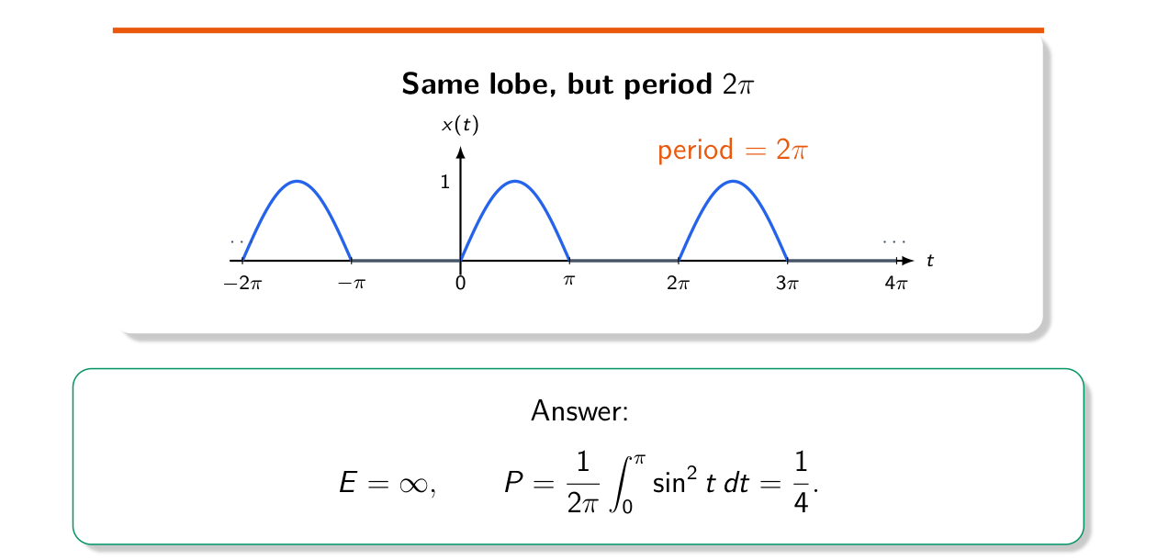
Figure 1.1 — Half-sine repeating with period 2π: infinite energy, power 1/4 (Lec 1, sl. 14)
An infinite-range signal with finite energy (sl. 15–16): x(t) = 1 for |t| ≤ 1, 1/|t| for |t| > 1.
E = ∫_{−1}^{1} 1 dt + 2 ∫₁^∞ t^{−2} dt = 2 + 2[−1/t]₁^∞ = 2 + 2 = 4
P∞ = 0 (finite energy spread over infinite time)

TRAP Infinite duration does not mean infinite energy: 1/|t| tails have finite energy because ∫ t⁻² converges. But 1/√|t| tails would give ∫ t⁻¹ = ∞. Always integrate |x|², not x.

Exam Approach
1. Sketch |x|² and decide what happens as t → ±∞: decays fast enough → try energy; settles to a nonzero level or is periodic → power; grows → neither.
2. Energy: integrate |x|² over the support (split piecewise signals).
3. Power: for periodic signals average one period; for signals that settle to constants c₋ (t → −∞) and c₊ (t → +∞), P∞ = (c₋² + c₊²)/2.
4. State the class in words: “E finite ⇒ energy signal, P = 0”.

Practice — Lesson 1
(a) Actual — EEE 211 2021-22 Q1(b). (b) Actual — EEE 211 2020-21 Q5(b). (c) Actual — EEE 211 2018-19 Q6(a)(i). (d) Practice set 1.1. (e) Older EEE papers, quick answers.
(a) Determine whether e^{−3t} sin(2πt/3 − 4) u(t) is a power or an energy signal. (10)
(b) Power or energy: (i) u(t − 6) − u(−t + 8); (ii) 2r(t − 4)u(t). (10)
(c) Is x₁(t) = exp[j(2πt + π/4)] + exp(−2|t|) a power or an energy signal? (part of 15)
(d) x(t) = t + 1 (−1 ≤ t < 0), 2 − t (0 ≤ t ≤ 2), 0 otherwise. Find its energy and its average power over [−1, 2].
(e) Classify: (i) e^{−t}cos 3t u(t); (ii) u(t) − 2u(t−2) + u(t−5); (iii) u(t) + 5u(t−1) − 2u(t−2); (iv) 2 sin(3πt/8) cos(2πt/3); (v) 1 for t < 0, e^{3t} for t ≥ 0; (vi) A e^{−t}u(t) and A e^{−a|t|} (a > 0).

✔ Solution
(a) |x|² ≤ e^{−6t} for t ≥ 0, so E ≤ ∫₀^∞ e^{−6t} dt = 1/6 < ∞ → energy signal (P∞ = 0). Exact value (write sin² = (1 − cos 2θ)/2 with ω = 2π/3):
E = ∫₀^∞ e^{−6t} sin²(ωt − 4) dt = 1/12 − (1/2) Re{ e^{−j8} / (6 − j2ω) }
= 1/12 − (6 cos 8 + 2ω sin 8) / (2(36 + 4ω²))
= 0.08333 − (−0.873 + 4.144)/107.09 = 0.0528

(b) (i) u(t − 6) = 1 for t > 6; u(8 − t) = 1 for t < 8. So x = −1 (t < 6), 0 (6 < t < 8), +1 (t > 8). E∞ = ∞, P∞ = [(−1)² + 1²]/2 = 1 → power signal, P = 1. (ii) 2r(t − 4)u(t) = 2(t − 4) for t ≥ 4: it grows without bound, (1/2T)∫(2(t−4))²dt → ∞ → neither.
(c) |x₁|² = 1 + e^{−4|t|} + 2e^{−2|t|}cos(2πt + π/4). The last two terms have finite area, so their contribution to (1/2T)∫ vanishes: P∞ = 1, E∞ = ∞ → power signal, P = 1 (the power of the exponential).
(d) Integrate each piece:
E = ∫_{−1}^{0} (t+1)² dt + ∫₀² (2−t)² dt = 1/3 + 8/3 = 3
P[−1,2] = E / 3 = 1

(e) (i) E = ∫₀^∞ e^{−2t}(1 + cos 6t)/2 dt = ½(½ + 2/40) = 0.275 → energy. (ii) 1 on (0,2), −1 on (2,5): E = 2 + 3 = 5 → energy. (iii) value 6 on (1,2), 4 for t > 2: P∞ = 4²/2 = 8 → power. (iv) = sin(25πt/24) − sin(7πt/24): two sinusoids of amplitude 1 → P = ½ + ½ = 1 → power. (v) grows as e^{3t} → neither. (vi) E = A²/2 and E = 2·A²/(2a) = A²/a → both energy signals.
NOTE EEE 301 2015-16 Q1(b)(iii) and EEE 211 2018-19 Q6(a)(ii) contain impulses δ(t − 2k) inside the signal. |δ|² is not defined, so the energy integral does not exist: classify as “neither” and say why.

Lesson 2 — Time Shifting, Reversal and Scaling
Slides 17–39 (Lec 1)

1. The Three Operations (sl. 18–25)
Operation | Rule (t0 > 0, α > 1) | Effect on a feature at t = a
Delay | x(t − t0) | moves right: a → a + t0
Advance | x(t + t0) | moves left: a → a − t0
Reversal | x(−t) | mirror about t = 0: a → −a
Compression | x(αt) | a → a/α (narrower)
Stretching | x(t/α) | a → αa (wider)
Amplitude scaling | A·x(t) | height × A, time unchanged

DT shifts work the same way: x[n − 4] moves every sample 4 places right (sl. 21). Time scaling changes only the horizontal axis, not the height (sl. 25).

2. Order Matters (sl. 26–27)
x(t) --shift left 3--> x(t+3) --compress by 2--> x(2t+3) ✓
x(t) --compress by 2--> x(2t) --shift left 3--> x(2(t+3)) = x(2t+6) ✗ (different!)

Each operation replaces t by something in the whole current expression. After compressing, a later shift of 3 becomes a shift of the argument by 6.

3. The Recipe for x(αt + β) (sl. 28–31)
x(t) → g₁(t) = x(t + β) → g₂(t) = g₁(−t) if α < 0 → g₃(t) = g₂(|α|t) = x(αt + β)
- Step 1 — shift by β (β > 0: left; β < 0: right).
- Step 2 — reverse only if α < 0.
- Step 3 — scale by |α| (|α| > 1 compress, |α| < 1 stretch).
- Write the intermediate signal after every step (sl. 30).
MEMORIZE Fast check (no sketch needed): a feature of x at t = a appears in x(αt + β) at t = (a − β)/α. Use it to find the new break points and the new support, then join them with the same shapes.

4. Worked Example: x(−3t + 2) (sl. 31–35)
x(t) = 1 on 0 ≤ t < 1, 2 − t on 1 ≤ t ≤ 2, 0 otherwise.
Step 1 x(t+2) = 1 on [−2,−1), −t on [−1,0]
Step 2 x(−t+2) = t on [0,1), 1 on [1,2]
Step 3 x(−3t+2) = 3t on [0,1/3), 1 on [1/3,2/3]
Check with t = (a − β)/α: a = 0 → t = 2/3; a = 1 → t = 1/3; a = 2 → t = 0 ✓

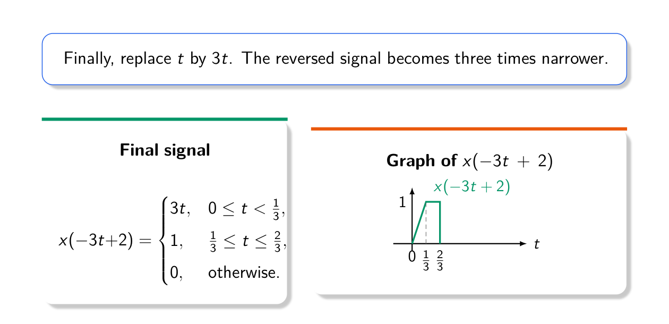
Figure 2.1 — The final compressed, reversed signal x(−3t + 2) (Lec 1, sl. 35)

5. Two Practice Problems from the Slides (sl. 36–39)
Practice 1: x(3(2 − t/2)) = x(6 − 3t/2): shift left by 6 → x(t + 6); reverse → x(−t + 6); compress by 3/2 → x(−3t/2 + 6).
Practice 2: start with x(t) and stretch by 2, shift left by 3, compress by 4, reverse:
y1 = x(t/2); y2 = y1(t+3) = x((t+3)/2); y3 = y2(4t) = x(2t + 3/2); y4 = y3(−t) = x(−2t + 3/2)

TRAP • A shift applied after scaling acts on t, not on αt: from x(2t), “shift left by 3” gives x(2(t+3)). • Reversal and scaling commute, but neither commutes with a shift. • Keep jumps (vertical edges) as jumps — they only move, they never become slopes.

Exam Approach
1. Write x(t) piecewise first (the papers give 3 marks just for this).
2. Rewrite the argument as αt + β (expand brackets: −2(t − 1) = −2t + 2).
3. Apply the recipe: shift, reverse if α < 0, scale; name each intermediate signal and the property used.
4. Map every break point with t = (a − β)/α; check one interior value by direct substitution.
5. For sums such as x(·) + x(·), sketch each term separately, then add point by point.

Practice — Lesson 2
(a) Actual — CSE 219 2022-23 Q7(a)–(c). (b) Actual — CSE 219 2023-24 Q1(a). (c) Actual — CSE 219 2022-23 Q7(d). (d) Actual — EEE 301 2010-11 Q5(b)(ii). (e) Adapted — EEE 211 2016-17 Q5(b).
(a) x(t) of Figure 2 is 0 for t < −2 and t > 2: it rises linearly from −1 at t = −2 to 0 at t = −1, jumps to 1 and stays at 1 up to t = 0, then falls linearly to 0 at t = 2. (i) Write x(t) piecewise. (ii) Determine and draw x(−2t + 2), naming the properties used. (iii) Determine and draw x(−t/2 + 1). (3 + 10 + 10)
(b) x(t) = 1 − |t| for |t| ≤ 1, 0 otherwise. Sketch y(t) = x(−2(t − 1)) + x((t + 2)/2), showing the effect of each operation on the two components. (15)
(c) An image is a discrete signal. Which signal property/operation is useful for: compression, blurring, sharpening, flipping, zooming, contrast, edge detection? (7)
(d) x(t) = −t + 1 (−1 ≤ t < 0), t (0 ≤ t < 2), 2 (2 ≤ t < 3), 0 otherwise. Find x(t − 2), x(t + 3), x(−3t − 2) and x(2t/3 + 1/2) analytically.
(e) If y(t) = x(−2t + 6) is known, how do you recover x(t)?

✔ Solution
(a) (i) x(t) = t + 1 for −2 ≤ t < −1; 1 for −1 ≤ t ≤ 0; 1 − t/2 for 0 < t ≤ 2; 0 otherwise.
(ii) x(−2t+2): α = −2, β = 2
Step 1 (time shift, left by 2): g1 = x(t+2) = t+3 on [−4,−3), 1 on [−3,−2], −t/2 on (−2,0]
Step 2 (time reversal): g2 = x(−t+2) = t/2 on [0,2), 1 on [2,3], 3−t on (3,4]
Step 3 (time compression by 2): x(−2t+2) = t on [0,1), 1 on [1,1.5], 3−2t on (1.5,2]
Check: t = 2 → x(−2) = −1 and 3 − 4 = −1 ✓; t = 1 → x(0) = 1 ✓

(iii) x(−t/2+1): α = −1/2, β = 1
Step 1 (shift left 1): x(t+1) = t+2 on [−3,−2), 1 on [−2,−1], (1−t)/2 on (−1,1]
Step 2 (reversal): x(−t+1) = (1+t)/2 on [−1,1), 1 on [1,2], 2−t on (2,3]
Step 3 (stretch by 2): x(−t/2+1) = 1/2 + t/4 on [−2,2), 1 on [2,4], 2 − t/2 on (4,6]
Check: t = 6 → x(−2) = −1 and 2 − 3 = −1 ✓; t = −2 → x(2) = 0 ✓

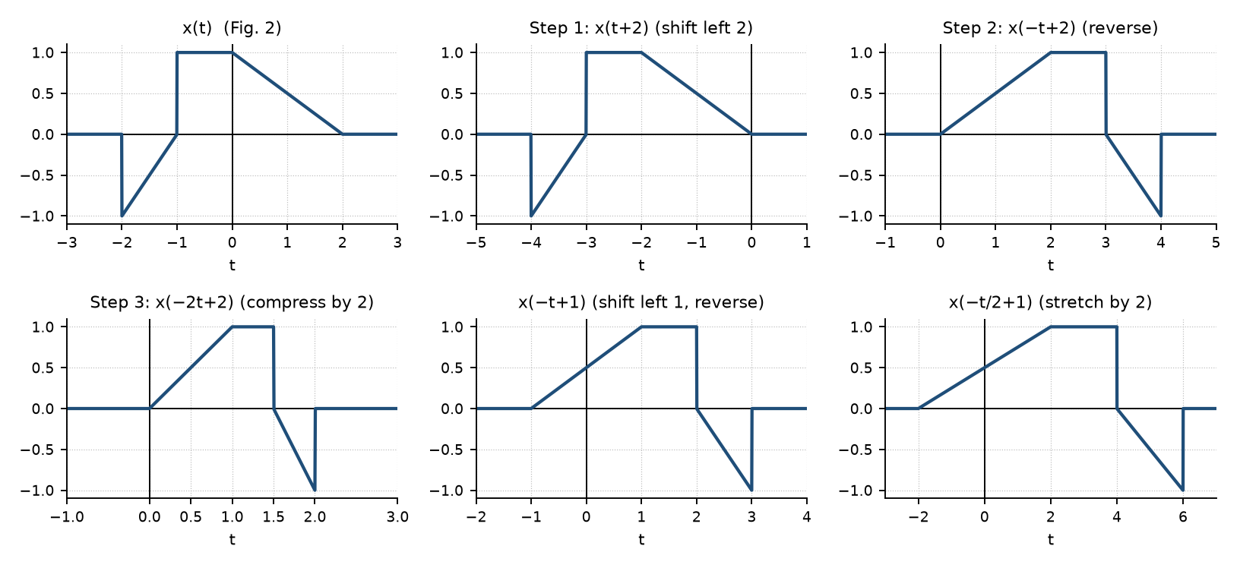
Figure 2.2 — CSE 219 2022-23 Q7: x(t), the three steps to x(−2t+2), and x(−t/2+1)
(b) First component x(−2(t − 1)) = x(−2t + 2): shift left 2 → triangle centred at −2; reverse → centred at +2; compress by 2 → centred at t = 1, half-width 1/2 (feature at a = 0 → t = (0 − 2)/(−2) = 1; a = ±1 → t = ½, 3/2). Reversal changes nothing visible because the triangle is even. Second component x((t + 2)/2) = x(t/2 + 1): shift left 1 → centred at −1; stretch by 2 → centred at t = −2, half-width 2 (a = ±1 → t = 0, −4). The two triangles do not overlap, so:
y(t) = (t+4)/2 −4 ≤ t ≤ −2
−t/2 −2 < t ≤ 0
2t − 1 1/2 ≤ t ≤ 1
3 − 2t 1 < t ≤ 3/2
0 otherwise (peaks y(−2) = y(1) = 1)

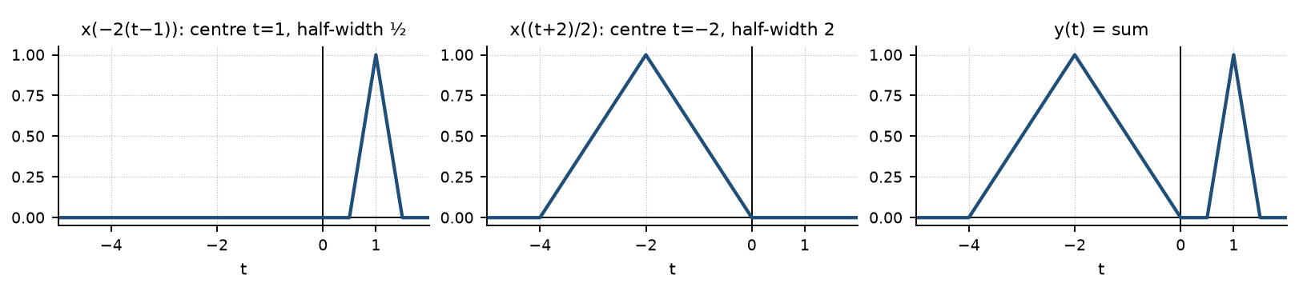
Figure 2.3 — CSE 219 2023-24 Q1(a): the two transformed triangles and their sum
(c) Compression — frequency content (Fourier/DCT): keep large low-frequency coefficients, drop small high-frequency ones. Blurring — convolution with an averaging (low-pass) kernel. Sharpening — high-pass filtering / adding back a differentiated (difference) image. Flipping — time (index) reversal x[−n] (x[−m, n] for a horizontal flip). Zooming — time (index) scaling: up-/down-sampling with interpolation. Contrast — amplitude scaling (and shifting) of pixel values; the spread (power/variance) of the values measures it. Edge detection — first difference x[n] − x[n−1] (derivative), i.e. high frequencies.
(d) Map each interval endpoint with t = (a − β)/α and keep the formula of each piece:
x(t−2) : shift right 2: −t+3 on [1,2), t−2 on [2,4), 2 on [4,5)
x(t+3) : shift left 3 : −t−2 on [−4,−3), t+3 on [−3,−1), 2 on [−1,0)
x(−3t−2) : a = −3t−2, t = −(a+2)/3:
a ∈ [−1,0) → t ∈ (−2/3,−1/3]: x = −a+1 = 3t+3
a ∈ [0,2) → t ∈ (−4/3,−2/3]: x = a = −3t−2
a ∈ [2,3) → t ∈ (−5/3,−4/3]: x = 2
x(2t/3+1/2): a = 2t/3+1/2, t = 3(a − 1/2)/2:
a ∈ [−1,0) → t ∈ [−9/4,−3/4): x = −a+1 = 1/2 − 2t/3
a ∈ [0,2) → t ∈ [−3/4, 9/4): x = 2t/3 + 1/2
a ∈ [2,3) → t ∈ [9/4, 15/4): x = 2

(e) Undo the operations in reverse order: y(t) = x(−2t + 6) ⇒ x(t) = y((6 − t)/2) = y(−t/2 + 3). Recipe on y: shift left by 3, reverse, stretch by 2. Every feature of y at t = b goes to t = 6 − 2b.

Lesson 3 — Even and Odd Decomposition
Slides 40–52 (Lec 1)

1. Definitions (sl. 41–44)
- Even: x(−t) = x(t) (mirror about the vertical axis), e.g. cos t.
- Odd: x(−t) = −x(t) (point symmetry about the origin), e.g. sin t. An odd signal has x(0) = 0.
x_e(t) = ½[x(t) + x(−t)] x_o(t) = ½[x(t) − x(−t)]
x(t) = x_e(t) + x_o(t)
Checks (sl. 44): x_e(−t) = ½[x(−t) + x(t)] = x_e(t); x_o(−t) = ½[x(−t) − x(t)] = −x_o(t); adding them gives x(t). The same formulas hold in DT with n in place of t.

2. Worked Examples (sl. 45–52)
x(t) = t + 1 on −1 ≤ t ≤ 1: x(−t) = 1 − t, so x_e = ½[(t+1) + (1−t)] = 1 and x_o = ½[(t+1) − (1−t)] = t, both on |t| ≤ 1.
DT step x[n] = u[n]: x_e[n] = ½ for n ≠ 0 and 1 at n = 0; x_o[n] = −½ (n < 0), 0 (n = 0), ½ (n > 0).
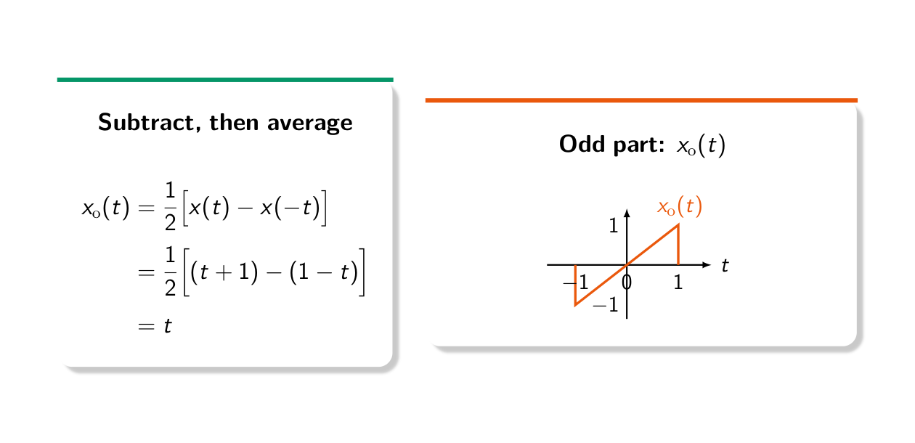
Figure 3.1 — Odd part of x(t) = t + 1 on [−1, 1] is x_o(t) = t (Lec 1, sl. 48)
MEMORIZE Useful facts: even × even = even, odd × odd = even, even × odd = odd. ∫_{−a}ª odd = 0. The area of x_e equals the area of x (the odd part adds zero area). x_e(0) = x(0), x_o(0) = 0.

TRAP Work interval by interval: x(−t) has its pieces on the mirrored intervals, so on each sub-interval you must combine the correct piece of x(t) with the correct piece of x(−t) (one of them may be 0). Do not just replace t by −t inside one formula.

Exam Approach
1. Write x(t) piecewise and list all break points ±a.
2. Write x(−t) piecewise (mirror the intervals, replace t by −t in each formula).
3. Cut the axis at all break points of both and compute ½(x ± x(−t)) on each piece.
4. Sketch: x_e must be mirror-symmetric, x_o must be point-symmetric — use this as a check.

Practice — Lesson 3
(a) Actual — CSE 219 2022-23 Q5(a). (b) Actual — EEE 301 2014-15 Q1(c). (c) Actual — EEE 301 2010-11 Q5(a)(ii).
(a) f(t) = t + 1 (−2 ≤ t ≤ 0), −t/2 + 1 (0 < t ≤ 2), 0 elsewhere. (i) Draw f(t). (ii) Find its even–odd decomposition using the definitions. (iii) Draw both parts. (3 + 6 + 6)
(b) x(t) = −t + 1 (−1 ≤ t < 0), t (0 ≤ t < 2), 2 (2 ≤ t < 3), 0 otherwise. Find the odd and even parts and their average values. (20)
(c) Find and sketch the odd and even parts of x(t) = A e^{−αt}, t > 0, and 0 otherwise.

✔ Solution
(a) f(−t) = −t + 1 for 0 ≤ t ≤ 2 and t/2 + 1 for −2 ≤ t < 0.
For 0 < t ≤ 2: f_e = ½[(−t/2 + 1) + (−t + 1)] = 1 − 3t/4 f_o = ½[(−t/2 + 1) − (−t + 1)] = t/4
For −2 ≤ t < 0: f_e = ½[(t + 1) + (t/2 + 1)] = 1 + 3t/4 f_o = ½[(t + 1) − (t/2 + 1)] = t/4

f_e(t) = 1 − 3|t|/4, |t| ≤ 2 (0 elsewhere) f_o(t) = t/4, |t| ≤ 2 (0 elsewhere)
Check: f_e + f_o at t = 1 → 1/4 + 1/4 = 1/2 = −1/2 + 1 ✓; at t = −1 → 1/4 − 1/4 = 0 = −1 + 1 ✓

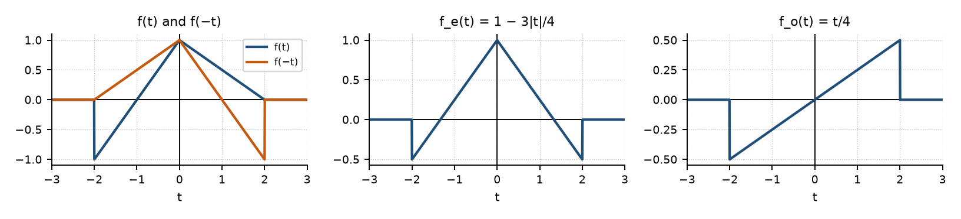
Figure 3.2 — CSE 219 2022-23 Q5(a): f(t), its even part (a ‘tent’) and its odd part (a line)
(b) x(−t) = t + 1 on (0, 1], −t on (−2, 0], 2 on (−3, −2]. Combining interval by interval:
interval x(t) x(−t) x_e = ½(x + x(−t)) x_o = ½(x − x(−t))
(−3,−2) 0 2 1 −1
(−2,−1) 0 −t −t/2 t/2
(−1, 0) −t+1 −t −t + 1/2 1/2
( 0, 1) t t+1 t + 1/2 −1/2
( 1, 2) t 0 t/2 t/2
( 2, 3) 2 0 1 1

Average values over the support (−3, 3): the odd part averages to 0 (odd function on a symmetric interval). The even part has the same area as x: ∫x = 1.5 + 2 + 2 = 5.5, so its average is 5.5/6 ≈ 0.917. (Over all time both averages are 0, because the signal has finite duration.)
(c) x_e(t) = (A/2) e^{−α|t|} (all t); x_o(t) = (A/2) e^{−αt} for t > 0 and −(A/2) e^{αt} for t < 0, i.e. (A/2) sgn(t) e^{−α|t|}. At t = 0: x_e = A/2 (taking x(0) = A/2), x_o = 0.

Lesson 4 — Unit Step, Unit Impulse, Ramp and Signals Built from Them
Slides 2–29 (Lec 2) · ramp, impulse scaling and δ′(t) are textbook background

1. Discrete-Time Step and Impulse (sl. 3–15)
u[n] = 1 (n ≥ 0), 0 (n < 0) δ[n] = 1 (n = 0), 0 (n ≠ 0)
- R1 — first difference: δ[n] = u[n] − u[n − 1] (sl. 11).
- R2 — running sum: u[n] = Σ_{m=−∞}^{n} δ[m] — the spike at m = 0 is included only when n ≥ 0 (sl. 12–13).
- R3 — sum of delayed impulses: u[n] = Σ_{k=0}∞ δ[n − k] (sl. 14–15).
- Values: u[1] = 1, u[−3] = 0, u[0] = 1; δ[0] = 1, δ[4] = δ[−2] = 0 (sl. 7–8). u[n − 2] starts at n = 2, u[n + 3] at n = −3 (sl. 9–10).

2. Continuous-Time Step and Impulse (sl. 16–27)
u(t) = 0 for t < 0, 1 for t > 0 (the value at t = 0 does not matter). The impulse should be the derivative of the step, but u(t) has no ordinary derivative at the jump. Fix (sl. 20–25): replace the jump by a short ramp u_Δ(t) rising from 0 to 1 over [0, Δ]. Its derivative δ_Δ(t) is a pulse of height 1/Δ and width Δ — area 1 for every Δ. As Δ → 0 the pulse becomes the ideal impulse:
δ(t) = du(t)/dt u(t) = ∫_{−∞}^{t} δ(τ) dτ ∫ δ(t) dt = 1
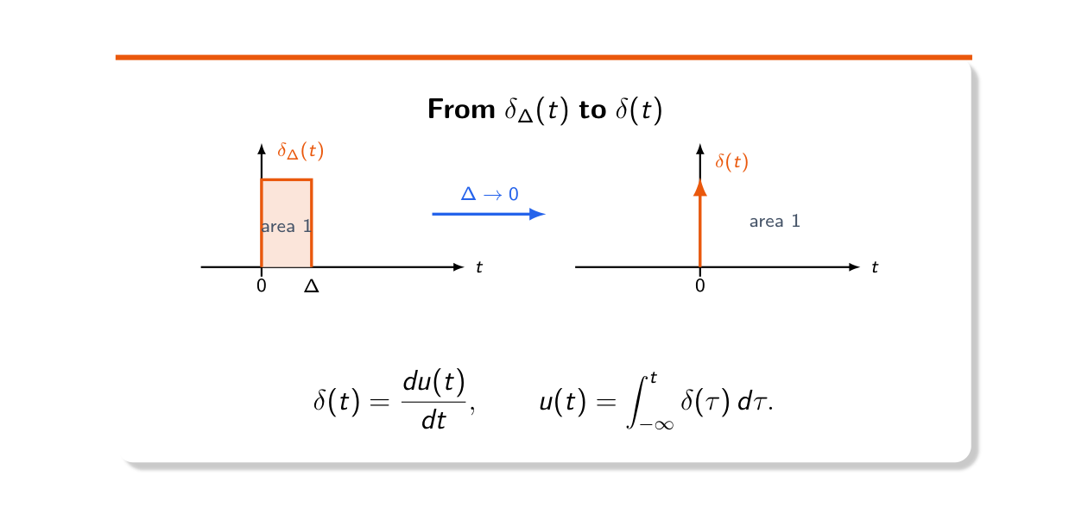
Figure 4.1 — δ(t) is the limit of unit-area pulses δ_Δ(t) as Δ → 0 (Lec 2, sl. 25)
Arrow notation (sl. 26): the number beside the arrow is the area (strength), not the height; 2δ(t − 1) is an arrow of strength 2 at t = 1, −3δ(t − 3) points down. d/dt[2u(t)] = 2δ(t) (sl. 27).

3. Signals Made of Steps; Derivatives at Jumps (sl. 28–29)
Read the jumps from left to right: x(t) jumps +2 at t = 1, −3 at t = 2 and +2 at t = 4, so
x(t) = 2u(t−1) − 3u(t−2) + 2u(t−4)
dx/dt = 2δ(t−1) − 3δ(t−2) + 2δ(t−4) (each jump → an impulse equal to the jump height)

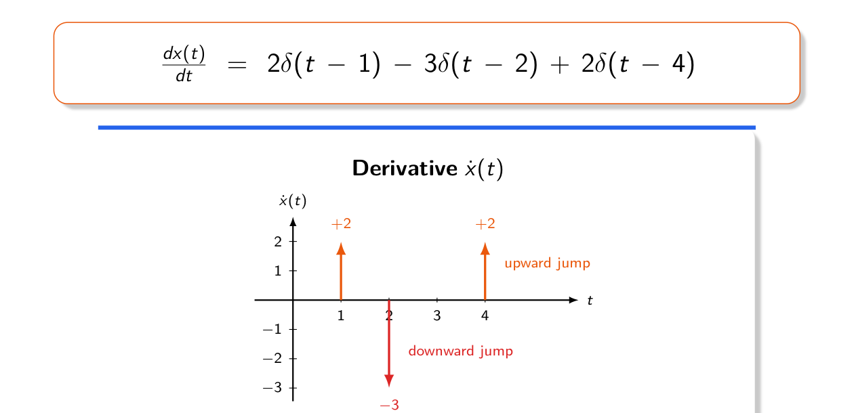
Figure 4.2 — Derivative of a jump signal: upward jumps give positive impulses (Lec 2, sl. 29)

4. Ramp and More Impulse Rules (textbook)
Rule | Statement
Ramp | r(t) = t u(t) = ∫_{−∞}^{t} u(τ)dτ; dr/dt = u(t)
Sampling (product) | x(t) δ(t − a) = x(a) δ(t − a)
Sifting | ∫_{L}^{R} x(t) δ(t − a) dt = x(a) if L < a < R, 0 if a is outside (Lec 6, sl. 45–51)
Scaling | δ(at + b) = (1/|a|) δ(t + b/a); δ(−t) = δ(t) (even)
Composite | δ(f(t)) = Σ δ(t − tᵢ)/|f′(tᵢ)| over the simple zeros tᵢ of f
Doublet | ∫ x(t) δ′(t − a) dt = −x′(a); δ′ is odd: δ′(−t) = −δ′(t)
Building blocks | slope change of m at t = a → m·r(t − a); jump of J at t = a → J·u(t − a)

Model of δ(t) (needed in EEE 2022-23 Q6(a), 2013-14 Q1(b)): a family p_ε(t) represents δ(t) as ε → 0 if (1) its area is 1 for every ε, (2) p_ε(t) → 0 for every t ≠ 0, and (3) it becomes infinitely tall at t = 0 (all the area concentrates at the origin).
MEMORIZE Piecewise linear signal → elementary signals: scan left to right; at each break point add (new slope − old slope)·r(t − a) and (jump)·u(t − a). Derivative: replace r by u and u by δ.

TRAP • u(3t) = u(t) and u(−2t) = u(−t): scaling a step by a positive number changes nothing. • δ(3t − k) = (1/3)δ(t − k/3), not δ(t − k/3). • Impulses at a jump are part of the derivative — the answer “slope only” loses most of the marks.

Exam Approach
1. Tabulate break points, slopes and jumps from the figure.
2. Write x(t) = Σ (slope changes)·r(t − a) + Σ (jumps)·u(t − a); check two values.
3. Derivative: piecewise slopes (rectangles) + impulses of strength = jump; second derivative: impulses at slope changes.
4. Impulse integrals: find where the argument of δ is zero, scale by 1/|a|, check the point is inside the limits, then sift.

Practice — Lesson 4
(a) Actual — EEE 211 2023-24 Q1(a). (b) Actual — EEE 211 2022-23 Q5(c). (c) Actual — EEE 211 2020-21 Q5(a). (d) Actual — EEE 211 2019-20 Q5(a).
(a) x(t) is a triangle from (−2, 0) up to (−1, 1) and down to (0, 0), then a ramp from (0, 0) to (2, 2), flat at 2 until t = 3, and a line down to 0 at t = 4. (i) Draw x(−3t + 2), x′(t), x″(t). (ii) Express x′(t) using δ(t), u(t), r(t). (11)
(b) x(t) = 5t on (0, 1), −6 on (1, 2), 5(t − 2) on (2, 3), 0 elsewhere. Write x(t) as a combination of elementary signals and sketch dx/dt. (10)
(c) x₁(t): ramp from 0 to 2 on [0, 2], then 2 until t = 6. x₂(t): ramp from 0 at t = −4 to 2 at t = −2, 2 until t = 2, 3 on (2, 4). x₃(t): rises from 0 at t = −3 to 4 at t = −2, stays 4 until t = 0, then 1 until t = 2, then falls to 0 at t = 3. (i) Express x₁, x₂ with r and u. (ii) Draw x₁(t + 2)r(t − 2) and x₂(t − 2)u(−2t). (iii) Express x₃ in terms of x₁. (10 + 10 + 5)
(d) x(t) = 2 on (−1.5, 0), 2e^{−t/2} on (0, 3), 0 elsewhere. Describe x(t) by a single expression valid for all t and sketch x(3t). (15)

✔ Solution
(a) x(t) = t+2 [−2,−1]; −t [−1,0]; t [0,2]; 2 [2,3]; 8−2t [3,4]; 0 otherwise
(i) x(−3t+2): a feature at a goes to t = (2 − a)/3:
a = 4,3,2,0,−1,−2 → t = −2/3, −1/3, 0, 2/3, 1, 4/3 with values 0, 2, 2, 0, 1, 0
x(−3t+2) = 6t+4 [−2/3,−1/3]; 2 [−1/3,0]; 2−3t [0,2/3]; 3t−2 [2/3,1]; 4−3t [1,4/3]
x′(t) = 1 (−2,−1); −1 (−1,0); 1 (0,2); 0 (2,3); −2 (3,4) (continuous x ⇒ no impulses)
x″(t) = δ(t+2) − 2δ(t+1) + 2δ(t) − δ(t−2) − 2δ(t−3) + 2δ(t−4)
(ii) x′(t) = u(t+2) − 2u(t+1) + 2u(t) − u(t−2) − 2u(t−3) + 2u(t−4)
[equivalently x(t) = r(t+2) − 2r(t+1) + 2r(t) − r(t−2) − 2r(t−3) + 2r(t−4)]

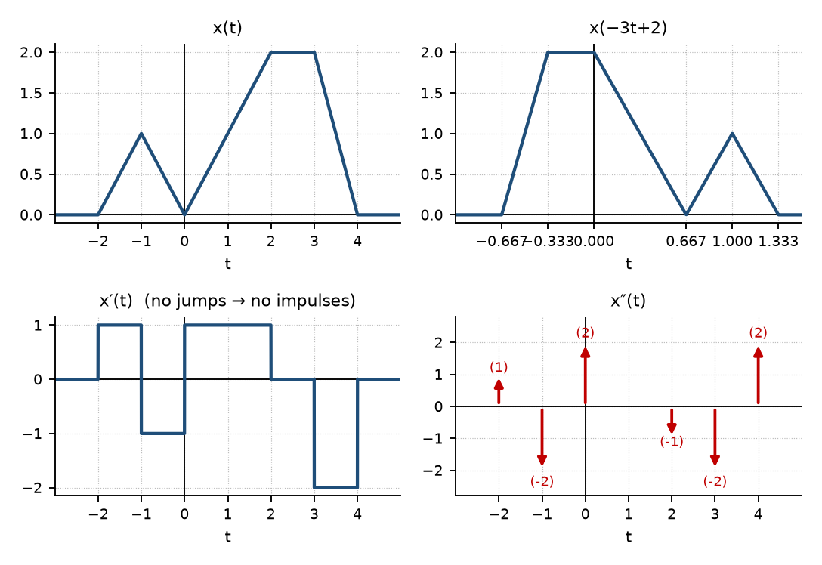
Figure 4.3 — EEE 211 2023-24 Q1(a): x(t), x(−3t+2), x′(t) and x″(t)
(b) Scan left to right: slope 5 starts at 0; at t = 1 slope 5 → 0 and jump 5 → −6 (−11);
at t = 2 jump −6 → 0 (+6) and slope 0 → 5; at t = 3 slope 5 → 0 and jump 5 → 0 (−5).
x(t) = 5r(t) − 5r(t−1) − 11u(t−1) + 6u(t−2) + 5r(t−2) − 5r(t−3) − 5u(t−3)
dx/dt = 5[u(t) − u(t−1)] + 5[u(t−2) − u(t−3)] − 11δ(t−1) + 6δ(t−2) − 5δ(t−3)

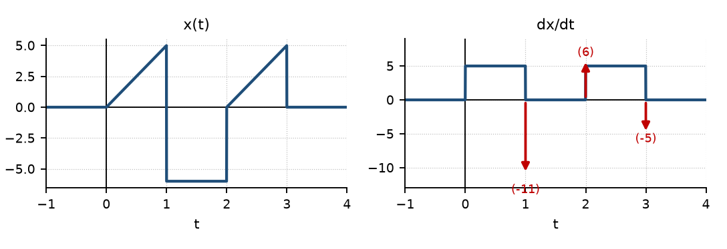
Figure 4.4 — EEE 211 2022-23 Q5(c): x(t) and dx/dt (rectangles of height 5 plus three impulses)
(c)(i) x₁(t) = r(t) − r(t−2) − 2u(t−6)
x₂(t) = r(t+4) − r(t+2) + u(t−2) − 3u(t−4)
(ii) x₁(t+2) = ramp on [−2,0], 2 on [0,4]; r(t−2) = t−2 for t ≥ 2 ⇒ product = 2(t−2) on [2,4], 0 elsewhere
x₂(t−2) = ramp 0→2 on [−2,0], 2 on [0,4], 3 on [4,6]; u(−2t) = u(−t) keeps t < 0 ⇒ product = t+2 on [−2,0]
(iii) Left part (ramp over 1 unit to 4, flat 2 units) = 2·x₁(2(t+3)) = 2x₁(2t+6)
Right part (1 on [0,2], ramp down to 0 at 3) = ½·x₁(−2(t−3)) = ½x₁(6−2t)
x₃(t) = 2x₁(2t+6) + ½x₁(6−2t) check: t = −1 → 2·2 + 0 = 4; t = 2.5 → 0 + ½·1 = 0.5 ✓

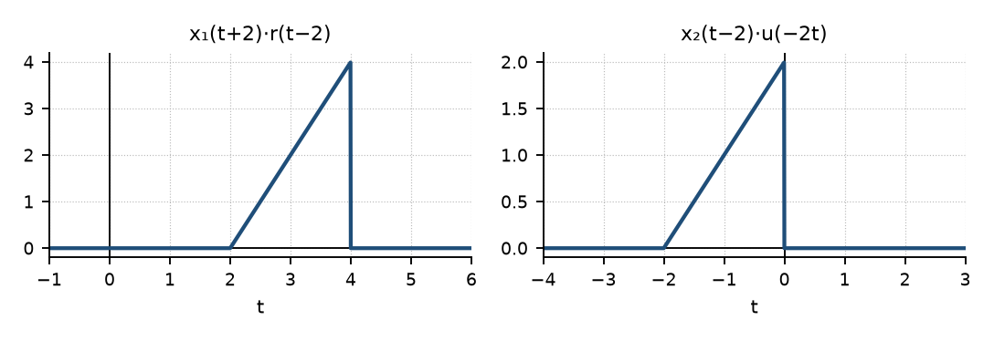
Figure 4.5 — EEE 211 2020-21 Q5(a)(ii): the two products
(d) x(t) = 2[u(t+1.5) − u(t)] + 2e^{−t/2}[u(t) − u(t−3)]
x(3t) = 2[u(t+0.5) − u(t)] + 2e^{−3t/2}[u(t) − u(t−1)] (break points −1.5, 0, 3 → −0.5, 0, 1)

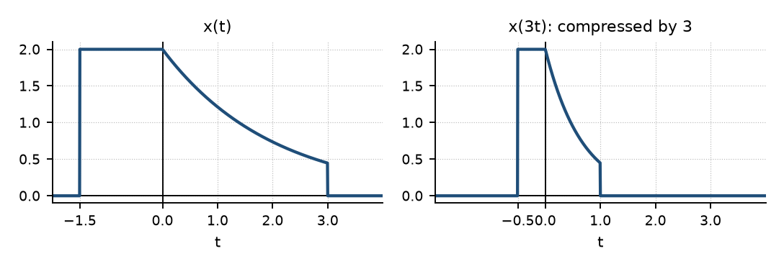
Figure 4.6 — EEE 211 2019-20 Q5(a): x(t) and x(3t)

Practice — Lesson 4 (continued)
(e) Actual — EEE 211 2022-23 Q6(a) and EEE 301 2013-14 Q1(b). (f) Actual — CSE 311 2019-20 Q2(b) and 2012-13 Q5(a). (g) Actual — EEE 211 2021-22 Q1(c). (h) Actual — EEE 301 2015-16 Q2(a), 2011-12 Q6(c), 2012-13 Q1(b).
(e) Check whether p₁(t) = lim_{ε→0} 1/(επ cosh(t/ε)) and p₂(t) = lim_{ε→0} (1/π) sin(εt)/t can be used as models of δ(t). Same for (1/π) ε/(t² + ε²). (20)
(f) Prove that a unit step can be derived from a unit impulse and vice versa. Define the unit impulse and derive its sampling property. (11; 8)
(g) x(t) = δ(t − 1) + u(t)u(t − 3) + u(cos t). Compute y(t) = ∫ x(τ)dτ and sketch y(t/2). (15)
(h) Evaluate: ∫(t² + 3t + 2)δ(−1 − t)dt; ∫e^{t−1} sin{π(t−5)/2} δ(t + 3)dt; ((jω+2)/(ω²+9))δ(ω); δ(ω−3)/(jω+2); ∫₋₅⁵ u₂(1 − τ)cos 2πτ dτ with u₂ = d²u/dt²; ∫e^{−5t+1}δ′(t − 5)dt. Also: is Σ_{k=−4}⁴ δ(3t − k) sin²(πt/3) a power or an energy signal?

✔ Solution
(e) Test the three conditions. p₁: substitute u = t/ε: ∫ dt/(επ cosh(t/ε)) = (1/π)∫ du/cosh u = (1/π)·π = 1 for every ε. For t ≠ 0, cosh(t/ε) ≈ ½e^{|t|/ε} → ∞ much faster than 1/ε grows, so p₁ → 0; p₁(0) = 1/(επ) → ∞. p₁ is a valid model of δ(t). p₂: area ∫ sin(εt)/(πt) dt = 1 for every ε > 0, but as ε → 0, sin(εt)/(πt) → 0 for every t (even the peak ε/π → 0) — the unit area spreads over a main lobe of width 2π/ε → ∞. p₂ is not a model as ε → 0 (it does become δ(t) as ε → ∞). Lorentzian (1/π)ε/(t² + ε²): area (1/π)[tan⁻¹(t/ε)]_{−∞}∞ = 1; → 0 for t ≠ 0; peak 1/(πε) → ∞ ⇒ valid model.
(f) Define δ(t) as the limit of the unit-area pulse δ_Δ(t) (height 1/Δ on [0, Δ]) as Δ → 0: δ(t) = 0 for t ≠ 0 and ∫δ = 1. (i) Step from impulse: u(t) = ∫_{−∞}^{t} δ(τ)dτ — for t < 0 the integration window does not contain the impulse (0), for t > 0 it does (1). (ii) Impulse from step: the smoothed step u_Δ rises from 0 to 1 over [0, Δ]; its derivative is δ_Δ, so δ(t) = lim du_Δ/dt = du/dt (in the generalized sense). Sampling property: since δ(t − a) = 0 except at t = a, x(t)δ(t − a) = x(a)δ(t − a); integrating, ∫x(t)δ(t − a)dt = x(a)∫δ(t − a)dt = x(a). (Rigorous version: ∫x(t)δ_Δ(t − a)dt = (1/Δ)∫_a^{a+Δ}x dt → x(a) for continuous x.)
(g) u(t)u(t − 3) = u(t − 3). u(cos t) = 1 whenever cos t > 0, i.e. a square wave of period 2π that is 1 on (−π/2 + 2kπ, π/2 + 2kπ). Its integral from −∞ diverges, so take the integral from 0 (the printed lower limit is not legible; state this assumption):
y(t) = ∫₀^t x dτ = u(t−1) + r(t−3) + w(t), t ≥ 0
w(t) = ∫₀^t u(cos τ)dτ: t on [0, π/2]; π/2 on [π/2, 3π/2]; π/2 + (t − 3π/2) on [3π/2, 5π/2]; …
(a staircase-ramp rising with slope 1 for half of each period, average slope 1/2)
y(t/2): replace t by t/2 — every break point doubles (1 → 2, 3 → 6, π/2 → π, 3π/2 → 3π, …)

(h) Results:
∫(t²+3t+2)δ(−1−t)dt = (t²+3t+2)|_{t=−1} = 1 − 3 + 2 = 0 [δ(−1−t) = δ(t+1)]
∫e^{t−1} sin{π(t−5)/2} δ(t+3)dt = e^{−4} sin(−4π) = 0
((jω+2)/(ω²+9)) δ(ω) = (2/9) δ(ω); δ(ω−3)/(jω+2) = δ(ω−3)/(2 + j3)
∫_{−5}^{5} δ′(1−τ) cos2πτ dτ = −∫δ′(τ−1)cos2πτ dτ = +d/dτ[cos2πτ]_{τ=1} = −2π sin 2π = 0
∫e^{−5t+1} δ′(t−5) dt = −d/dt[e^{−5t+1}]_{t=5} = 5e^{−24}
Σ_{k=−4}^{4} δ(3t−k) sin²(πt/3) = Σ (1/3) sin²(πk/9) δ(t − k/3): 8 nonzero impulses (k = 0 vanishes).
Each impulse has finite area but |δ|² is not integrable → E = ∞; with a finite number of impulses the
time-average P = lim E/2T is not finite either → neither (state the reason).

Lesson 5 — Exponentials, Sinusoids and Periodicity
Slides 30–50 (Lec 2)

1. Real Exponentials and the Step as a Switch (sl. 31–35)
x(t) = Ce^{at}: grows (a > 0), constant (a = 0), decays (a < 0). Multiplying by u(t) keeps only the part t > 0; u(t − 2) switches on at t = 2; u(3 − t) keeps t < 3; u(−t) keeps t < 0.
e^{t}u(−t): rising exponential, ends at 1 at t = 0 e^{−t}u(t−2): starts at e^{−2} at t = 2
e^{t}u(3−t): grows until t = 3, then 0 e^{−t}u(3t) = e^{−t}u(t)

2. Sinusoids and Complex Exponentials (sl. 36–42)
x(t) = A cos(ω0t + φ), T0 = 2π/|ω0| e^{jθ} = cos θ + j sin θ
cos θ = (e^{jθ} + e^{−jθ})/2 sin θ = (e^{jθ} − e^{−jθ})/2j
e^{jω0t} is a point rotating around the unit circle; cos and sin are its horizontal and vertical coordinates. A real cosine is two opposite rotations whose imaginary parts cancel (sl. 41). Period: e^{jω0T} = 1 ⇒ ω0T = 2π.

3. Discrete-Time Periodicity (sl. 43–50)
x[n] = cos(ω0n + φ) is periodic only if some integer N satisfies ω0N = 2πm. So 2π/ω0 must be rational: write 2π/ω0 = N/m in lowest terms; the fundamental period is N (after m cycles of the underlying cosine).
Signal | 2π/ω0 | Result
cos(2t) (CT) | — | periodic, T0 = π
cos(2n) | π (irrational) | not periodic
cos(2πn/5) | 5 | N = 5
3 sin(5n/7) | 14π/5 (irrational) | not periodic
2 cos(16πn/63 + π/3) | 63/8 | N = 63 (8 cycles of the cosine)

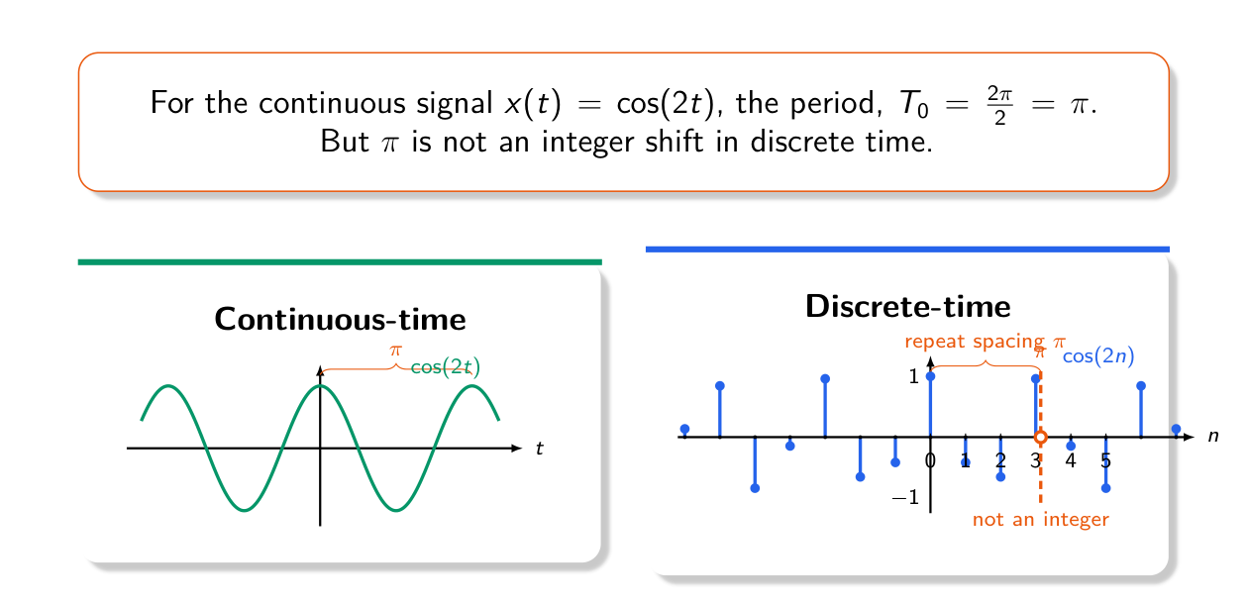
Figure 5.1 — cos(2t) repeats every π, but cos(2n) never repeats: π is not an integer shift (Lec 2, sl. 45)

4. Sums of Periodic Signals (textbook)
x₁ + x₂ (periods T₁, T₂) is periodic iff T₁/T₂ is rational; then T = LCM(T₁, T₂). Equivalently ω₁/ω₂ rational and ω0 = GCD(ω₁, ω₂). For DT sums: N = LCM(N₁, N₂) always exists if each part is periodic. Phase shifts never change a period. Powers and products: expand into sums of sinusoids first (sin²θ = (1 − cos 2θ)/2).
TRAP • The phase of a DT sinusoid does not affect periodicity (sl. 49). • In DT, ω0 = 2π·(m/N) gives period N, not 2π/ω0 (63/8 is not a period). • √(e^{j5πt}) = e^{j5πt/2}: halve the frequency. • An impulse train δ(t − kπ) has period π, u(cos t) has period 2π.

Exam Approach
1. Rewrite everything as a sum of sinusoids / complex exponentials (expand squares and products).
2. CT: list the periods Tᵢ = 2π/ωᵢ; check every ratio is rational; T = LCM.
3. DT: for each term check 2π/ωᵢ = N/m rational; Nᵢ = numerator; N = LCM(Nᵢ).
4. Write the conclusion with the reason (“ratio is irrational ⇒ not periodic”).

Practice — Lesson 5
(a) Actual — CSE 219 2022-23 Q5(c). (b) Actual — CSE 219 2023-24 Q3(a). (c) Actual — EEE 211 2021-22 Q1(a). (d) Older papers, quick answers (EEE 211 2017-18 Q5(a), 2016-17 Q5(c); EEE 301 2015-16 Q1(a), 2014-15 Q1(a), 2013-14 Q1(a), 2012-13 Q1(a), 2011-12 Q6(a), 2010-11 Q5(a)(i)).
(a) Is x[n] = 2cos(16πn/63 + π/3) periodic? Explain. (5)
(b) x[n] = (3 − 4j)e^{j13πn/7}. (i) Are the real and imaginary parts periodic? Fundamental period? (ii) Can the phase shift in each part be interpreted as an integer time shift of a cosine sequence? (15)
(c) Is x(t) = √(e^{j5πt}) + sin²(3t − π/4) periodic? If so, find the period. (10)
(d) Periodic? Period? (i) [2cos(0.6√π t + π/6) + sin(1.2√π t − π/3)]²; (ii) cos(100πt + π/3) + sin(40πt + 2π/3); (iii) 3cos(4t + π/3), [cos(2t − π/3)]², Σ_{n=−7}⁷ e^{−(2t−n)}, e^{j(πt−1)}; (iv) u(cos t) − δ(t − kπ); (v) 4cos πt − sin(3πt + π/2) and 4cos 2t + 4cos 2πt; (vi) αδ(sin t) + (1 − α)δ(t − kπ), k odd, 0 < α < 1; (vii) e^{j7πt/6} + e^{j5πt/6}; (viii) cos(πt/3) + sin(πt/4).

✔ Solution
(a) ω0 = 16π/63, 2π/ω0 = 63/8 = N/m with N = 63, m = 8 (rational). Periodic, N₀ = 63: after 63 samples the angle advances by 16π = 8 full turns. The phase π/3 does not matter.
(b) 3 − 4j = 5e^{−jθ}, θ = tan⁻¹(4/3) = 0.9273 rad. x[n] = 5e^{j(13πn/7 − θ)}, so Re x = 5cos(13πn/7 − θ), Im x = 5sin(13πn/7 − θ). (i) 2π/ω0 = 2π/(13π/7) = 14/13 → rational, N = 14 (13 cycles). Both parts are periodic with N₀ = 14. (ii) A time shift n₀ turns cos(13πn/7) into cos(13π(n − n₀)/7), a phase of −13πn₀/7, which is always a multiple of π/7 (mod 2π). θ = 0.9273 rad = 2.066·(π/7) is not a multiple of π/7 (in fact θ/π is irrational, since cos θ = 3/5 is rational but not 0, ±½, ±1). So no: the phase cannot be produced by an integer shift — it can only be read as a shift of the underlying CT cosine.
(c) √(e^{j5πt}) = e^{j5πt/2} (principal root): period 2π/(5π/2) = 4/5. sin²(3t − π/4) = ½ − ½cos(6t − π/2): period π/3. Ratio (4/5)/(π/3) = 12/(5π) is irrational ⇒ not periodic.
(d)(i) periods 10√π/3 and 5√π/3 (ratio 2); the square contains 0.6√π·{1,2,3,4} ⇒ T = 10√π/3 ≈ 5.91
(ii) T₁ = 1/50, T₂ = 1/20 ⇒ T = LCM = 0.1 s
(iii) π/2; π/2 (cos² = ½ + ½cos(4t − 2π/3)); e^{−2t}·const → not periodic; T = 2
(iv) u(cos t): 2π; impulse train: π ⇒ T = 2π
(v) T = 2 and 2/3 ⇒ T = 2; π and 1 (ratio π irrational) ⇒ not periodic
(vi) δ(sin t) = Σ_k δ(t − kπ) (|cos kπ| = 1) ⇒ weight α at even multiples of π, α + (1−α) = 1 at odd
multiples ⇒ periodic, T = 2π (α ≠ 1). For α = 0.5: ½ at 0, ±2π…; 1 at ±π, ±3π…
(vii) ω₀ = GCD(7π/6, 5π/6) = π/6 ⇒ T = 12
(viii) T₁ = 6, T₂ = 8 ⇒ T = 24

Quick Notes — Signals
Revision points for Lessons 1–5.

L1 · Energy and Power
- E = ∫|x|²dt (Σ|x[n]|²); P = E / interval length; P∞ = lim (1/2T)∫_{−T}^{T}|x|².
- Energy signal: E finite, P = 0. Power signal: P finite, E = ∞. Neither: both infinite.
- Periodic → power, average one period. A cos(ω0t + φ): P = A²/2; Ae^{jω0t}: P = |A|².
- Half-sine E = π/2; 1 (|t| ≤ 1), 1/|t| beyond: E = 4.

L2 · Transformations
- x(t − t0) delay (right); x(t + t0) advance (left); x(−t) mirror; x(αt) compress (α > 1).
- Recipe for x(αt + β): shift by β → reverse if α < 0 → scale by |α|. Name each intermediate signal.
- Feature at a moves to t = (a − β)/α. x(2t + 3) ≠ x(2(t + 3)).
- 2022-23 Q7: x(−2t+2) = t [0,1], 1 [1,1.5], 3 − 2t (1.5,2]; x(−t/2+1) = ½ + t/4 [−2,2], 1 [2,4], 2 − t/2 (4,6].

L3 · Even and Odd
- x_e = ½[x(t) + x(−t)], x_o = ½[x(t) − x(−t)]; work interval by interval.
- x = t+1 on [−1,1] → x_e = 1, x_o = t. u[n] → x_e = ½ (1 at 0), x_o = ±½.
- 2022-23 Q5(a): f_e = 1 − 3|t|/4, f_o = t/4 on |t| ≤ 2.

L4 · Step, Impulse, Ramp
- δ[n] = u[n] − u[n−1]; u[n] = Σ_{m≤n} δ[m] = Σ_{k≥0} δ[n−k]. δ(t) = du/dt; u(t) = ∫_{−∞}^{t} δ.
- Jump of J at a → Jδ(t − a) in the derivative; slope change m → m·r(t − a) in the signal.
- Sifting ∫x δ(t − a) = x(a) only if a is inside the limits; δ(at) = δ(t)/|a|; ∫x δ′(t − a) = −x′(a).
- δ model: unit area for all ε, → 0 for t ≠ 0, peak → ∞. sin(εt)/(πt) fails as ε → 0.

L5 · Periodicity
- CT: T0 = 2π/|ω0|; sum periodic iff period ratio rational, T = LCM.
- DT: periodic iff 2π/ω0 = N/m rational; N = numerator. cos 2n not periodic; 2cos(16πn/63 + π/3): N = 63.
- Phase never changes a period. Expand squares/products before deciding.

Key Diagrams to Reproduce
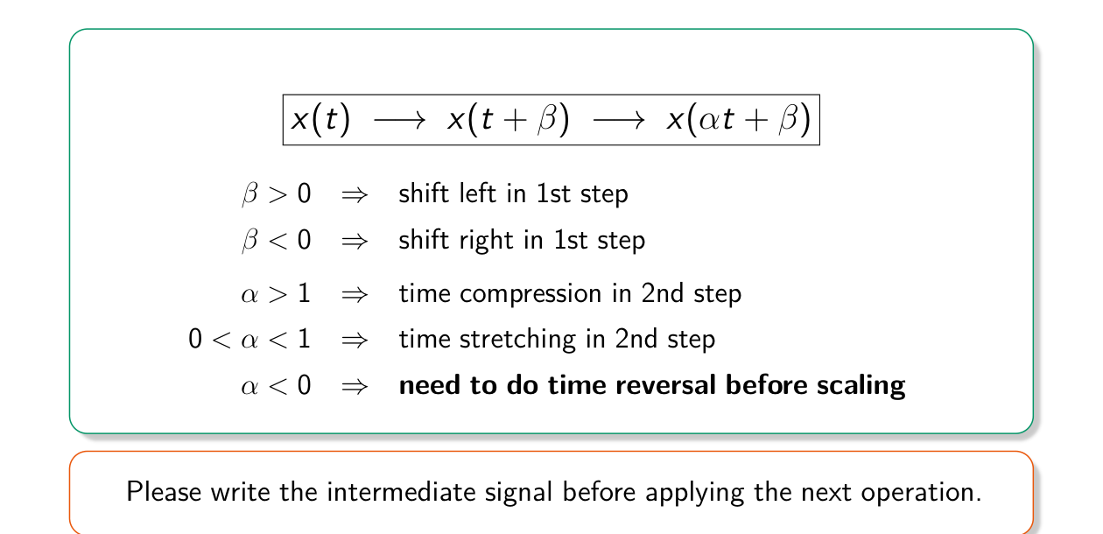
The x(αt + β) recipe (Lec 1, sl. 30)
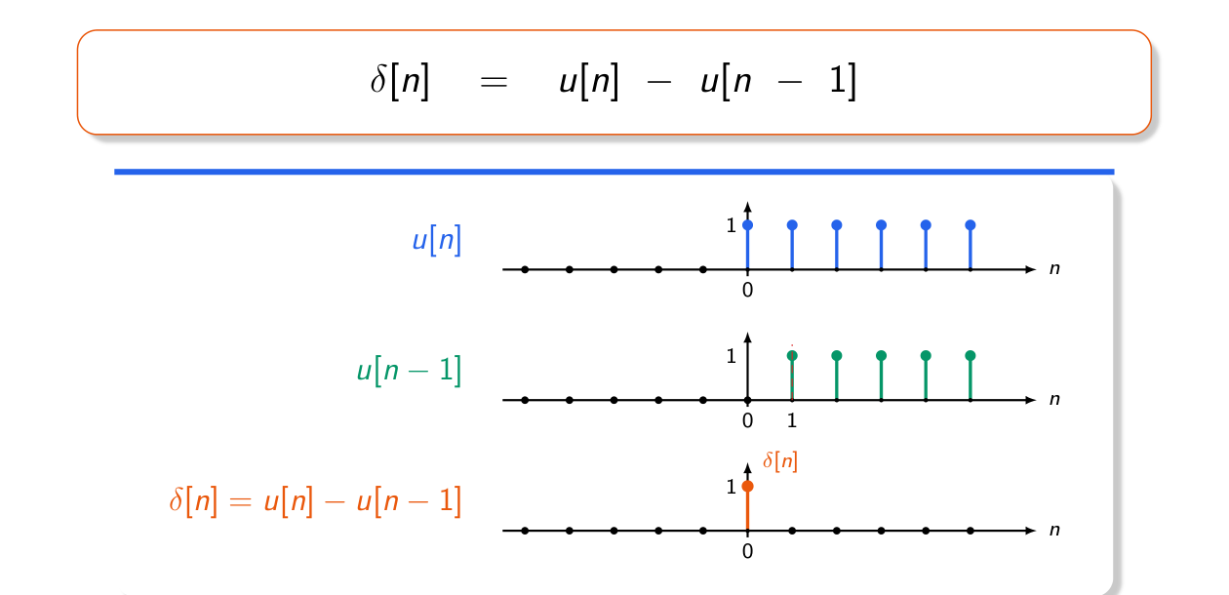
δ[n] = u[n] − u[n − 1] (Lec 2, sl. 11)

